**WEEK 6: REACT**

**1. ReactJS-HOL**

**Create a new React Application with the name “myfirstreact”, Run the application to print “welcome to the first session of React” as heading of that page.**

**Code:**

**App.js**

import React from 'react';

function App() {

  return (

    <div>

      <h1>Welcome to the first session of React</h1>

    </div>

  );

}

export default App;

**Output:**

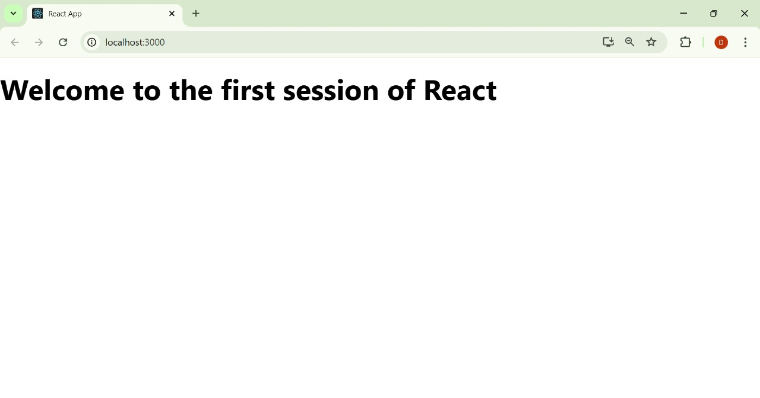

**2. ReactJS-HOL**

**Create a react app for Student Management Portal named StudentApp and create a component named Home which will display the Message “Welcome to the Home page of Student Management Portal”. Create another component named About and display the Message “Welcome to the About page of the Student Management Portal”. Create a third component named Contact and display the Message “Welcome to the Contact page of the Student Management Portal”. Call all the three components.**

**Code:**

**Home.js**

import React from 'react';

function Home() {

return (

<div>

<h1>Welcome to the Home page of Student Management Portal</h1>

</div>

);

}

export default Home;

**About.js**

import React from 'react';

function About() {

return (

<div>

<h1>Welcome to the About page of the Student Management Portal</h1>

</div>

);

}

export default About;

**Contact.js**

import React from 'react';

function Contact() {

return (

<div>

<h1>Welcome to the Contact page of the Student Management Portal</h1>

</div>

);

}

export default Contact;

**App.js**

import React from 'react';

import './App.css';

import Home from './Components/Home';

import About from './Components/About';

import Contact from './Components/Contact';

function App() {

return (

<div className="App">

<Home />

<About />

<Contact />

</div>

);

}

export default App;

**Output:**

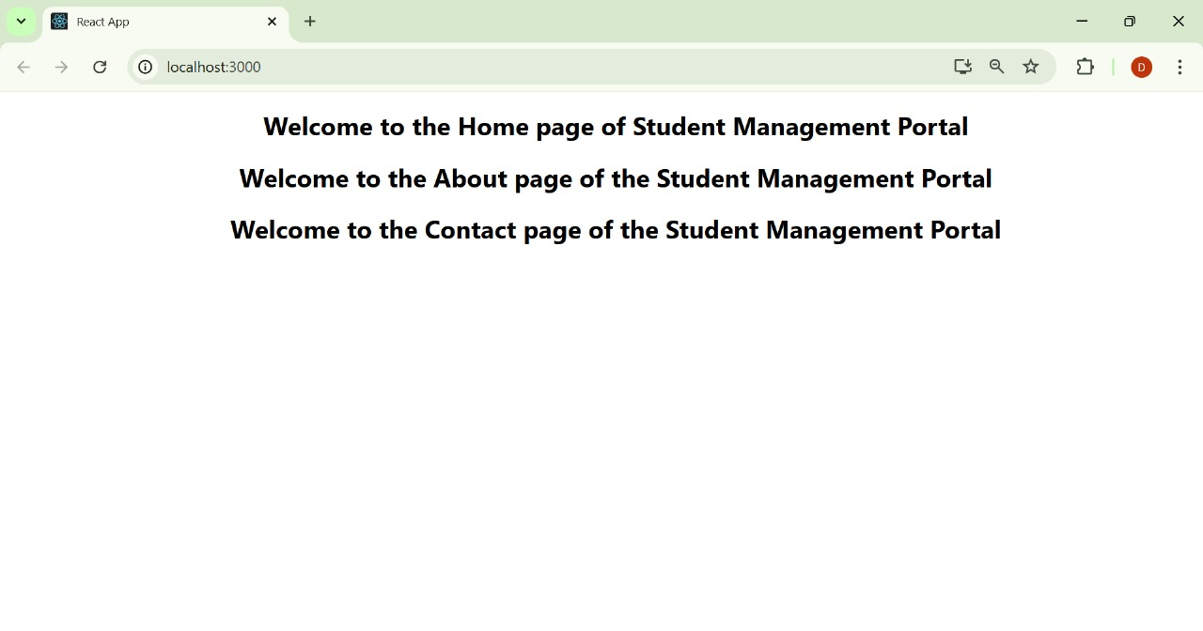

**3. ReactJS-HOL**

**Create a react app for Student Management Portal named scorecalculatorapp and create a function component named “CalculateScore” which will accept Name, School, Total and goal in order to calculate the average score of a student and display the same.**

**Code:**

**CalculateScore.js**

import React from 'react';

import '../Stylesheets/mystyle.css';

function CalculateScore(props) {

const average = (props.Total / props.Goal).toFixed(2); // 2 decimal places

return (

<div className="formatstyle">

<h2 className="heading">Student Details:</h2>

<div><strong className="Name">Name:</strong><span className="NameValue"> {props.Name}</span></div>

<div><strong className="School">School:</strong><span className="SchoolValue"> {props.School}</span></div>

<div><strong className="Total">Total:</strong><span className="TotalValue"> {props.Total}Marks</span></div>

<div><strong className="Score">Score:</strong><span className="ScoreValue"> {average}%</span></div>

</div>

);

}

export default CalculateScore;

**mystyle.css**

.heading {

color: brown;

font-weight: bold;

}

.Name {

color: blue;

}

.NameValue {

color: slateblue;

font-weight: normal;

}

.School {

color: crimson;

}

.SchoolValue {

color: palevioletred; /* or pick another if needed */

font-weight: normal;

}

.Total {

color: darkmagenta;

}

.TotalValue {

color: orchid; /* or choose another readable color */

font-weight: normal;

}

.Score {

color: green;

}

.ScoreValue {

color: forestgreen;

font-weight: normal;

}

.formatstyle {

text-align: center;

font-size: large;

margin-top: 50px;

}

**App.js**

import React from 'react';

import './App.css';

import CalculateScore from './Components/CalculateScore';

function App() {

return (

<div className="App">

<CalculateScore Name="Steeve" School="DNV Public School" Total={284} Goal={3} />

</div>

);

}

export default App;

**Output:**

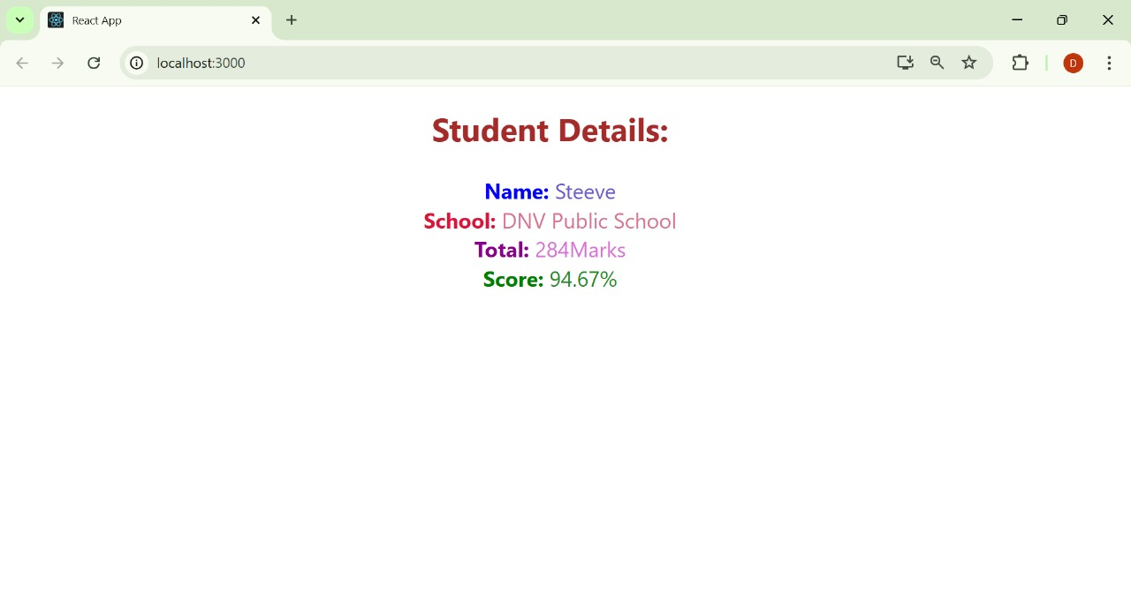

**3. ReactJS-HOL**

* **Implement componentDidMount() hook.**
* **Implementing componentDidCatch() life cycle hook**.

**Code:**

**Post.js**

import React from 'react';

class Post extends React.Component {

render() {

return (

<div style={{ border: '1px solid #ccc', padding: '10px', marginBottom: '10px' }}>

<h2>{this.props.title}</h2>

<p>{this.props.body}</p>

</div>

);

}

}

export default Post;

**Posts.js**

import React from 'react';

import Post from './Post';

class Posts extends React.Component {

constructor(props) {

super(props);

this.state = {

posts: [],

hasError: false

};

}

loadPosts = () => {

fetch("https://jsonplaceholder.typicode.com/posts")

.then((response) => response.json())

.then((data) => this.setState({ posts: data }))

.catch((error) => {

console.error("Error fetching posts:", error);

this.setState({ hasError: true });

});

};

componentDidMount() {

this.loadPosts();

}

componentDidCatch(error, info) {

alert("An error occurred in Posts component!");

console.error("Error caught in componentDidCatch:", error, info);

}

render() {

return (

<div>

<h1>All Posts</h1>

{this.state.posts.map((post) => (

<Post key={post.id} title={post.title} body={post.body} />

))}

</div>

);

}

}

export default Posts;

**App.js**

import React from 'react';

import './App.css';

import Posts from './Posts';

function App() {

return (

<div className="App">

<Posts />

</div>

);

}

export default App;

**Output:**

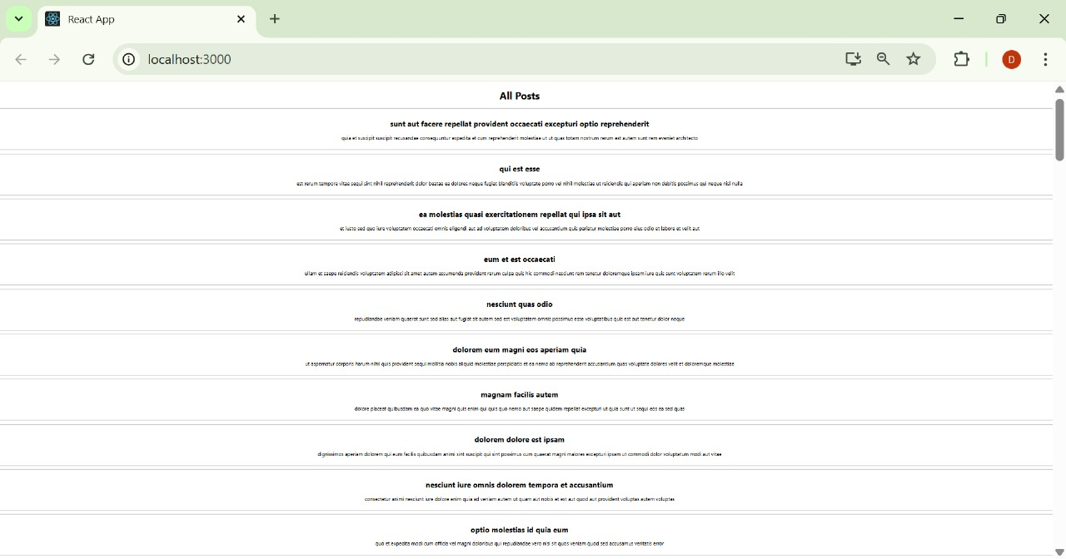

**5. ReactJS-HOL**

* **Style a react component**
* **Define styles using the CSS Module**
* **Apply styles to components using className and style properties**

**Code:**

**CohortDetails.js**

import React from 'react';

import styles from './CohortDetails.module.css';

const CohortDetails = ({ title, startDate, status, coach, trainer }) => {

const titleClass =

status.toLowerCase() === 'ongoing'

? styles['title-ongoing']

: styles['title-scheduled'];

return (

<div className={styles.box}>

<h3 className={titleClass}>{title}</h3>

<dl>

<dt>Started On</dt>

<dd>{startDate}</dd>

<dt>Current Status</dt>

<dd>{status}</dd>

<dt>Coach</dt>

<dd>{coach}</dd>

<dt>Trainer</dt>

<dd>{trainer}</dd>

</dl>

</div>

);

};

export default CohortDetails;

**CohortDetails.module.css**

.box {

width: 300px;

display: inline-block;

vertical-align: top;

margin: 10px;

padding: 10px 20px;

border: 1px solid black;

border-radius: 10px;

}

dt {

font-weight: 500;

}

.title-scheduled {

color: blue;

font-weight: bold;

}

.title-ongoing {

color: green;

font-weight: bold;

}

**App.js**

import React from 'react';

import CohortDetails from './CohortDetails';

const App = () => {

return (

<div>

<h2>Cohorts Details</h2>

<CohortDetails

title="INTADMDF10 -.NET FSD"

startDate="22-Feb-2022"

status="Scheduled"

coach="Aathma"

trainer="Jojo Jose"

/>

<CohortDetails

title="ADM21JF014 - Java FSD"

startDate="10-Sep-2021"

status="Ongoing"

coach="Apoorv"

trainer="Elisa Smith"

/>

<CohortDetails

title="CDBJF21025 - Java FSD"

startDate="24-Dec-2021"

status="Ongoing"

coach="Aathma"

trainer="John Doe"

/>

</div>

);

};

export default App;

**Output:**

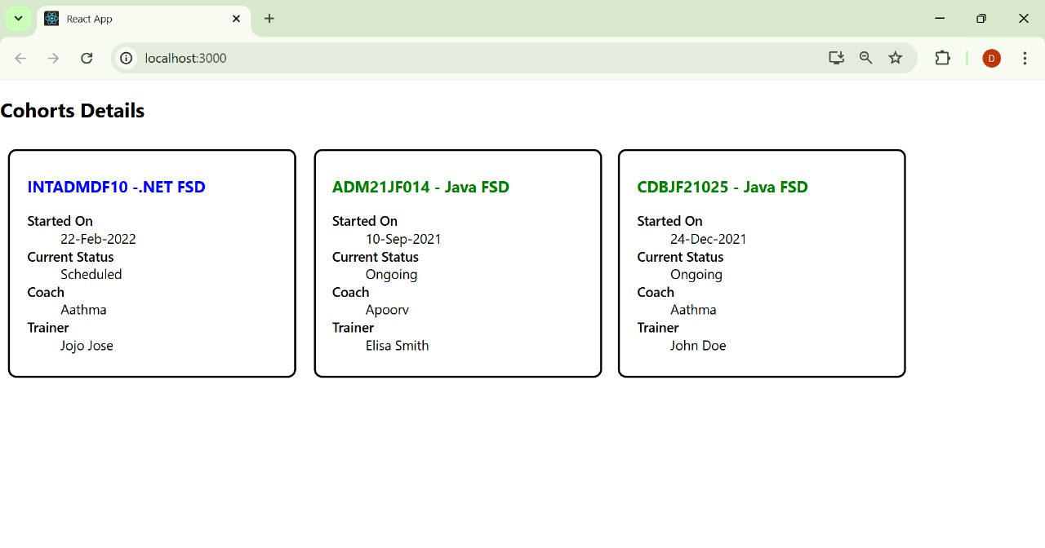

**6. ReactJS-HOL**

**Cognizant Academy teams want to maintain a list of trainers along with their expertise in a SPA using React as the technology. You are assigned the task of creating this React app.**

**The following trainers’ data application will deal.**

1. **T-ID**
2. **Name**
3. **Phone**
4. **Email**
5. **Stream**
6. **Skills**

**Code:**

**Trainer.js**

class Trainer {

constructor(TrainerId, Name, Email, Phone, Stream, Skills) {

this.TrainerId = TrainerId;

this.Name = Name;

this.Email = Email;

this.Phone = Phone;

this.Stream = Stream;

this.Skills = Skills;

}

}

export default Trainer;

**TrainersMock.js**

import Trainer from "./Trainer";

const TrainersMock = [

new Trainer(

't-syed8',

'Syed Khaleelullah',

'khaleelullah@cognizant.com',

'97676516962',

'.NET',

['C#', 'SQL Server', 'React', '.NET Core']

),

new Trainer(

't-jojo',

'Jojo Jose',

'jojo@cognizant.com',

'9897199231',

'Java',

['Java', 'JSP', 'Angular', 'Spring']

),

new Trainer(

't-elisa',

'Elisa Jones',

'elisa@cognizant.com',

'9871212235',

'Python',

['Python', 'Django', 'Angular']

)

];

export default trainersMock;

**TrainersList.js**

import React from 'react';

import { Link } from 'react-router-dom';

function TrainersList({ trainers }) {

return (

<div>

<h2>Trainers List</h2>

<ul>

{trainers.map((trainer) => (

<li key={trainer.TrainerId}>

<Link to={`/trainer/${trainer.TrainerId}`}>{trainer.Name}</Link>

</li>

))}

</ul>

</div>

);

}

export default TrainersList;

**Home.js**

import React from 'react';

function Home() {

  return (

    <div>

        <h1>My Academy Trainers App</h1>

      <h2>Welcome to My Academy trainers page</h2>

    </div>

  );

}

export default Home;

**TrainerDetail.js**

import React from 'react';

import { useParams } from 'react-router-dom';

import trainersMock from './trainersmock';

function TrainerDetail() {

const { id } = useParams();

const trainer = trainersMock.find(t => t.TrainerId === id);

if (!trainer) return <p>Trainer not found.</p>;

return (

<div>

<h2>Trainer Details</h2>

<p><strong>ID:</strong> {trainer.TrainerId}</p>

<p><strong>Name:</strong> {trainer.Name}</p>

<p><strong>Email:</strong> {trainer.Email}</p>

<p><strong>Phone:</strong> {trainer.Phone}</p>

<p><strong>Stream:</strong> {trainer.Stream}</p>

<p><strong>Skills:</strong> {trainer.Skills.join(', ')}</p>

</div>

);

}

export default TrainerDetail;

**App.js**

import React from 'react';

import { BrowserRouter as Router, Routes, Route, Link } from 'react-router-dom';

import Home from './Home';

import TrainersList from './TrainersList';

import TrainerDetail from './TrainerDetail';

import trainersMock from './trainersmock';

function App() {

return (

<Router>

<div>

<nav style={{ marginBottom: '20px' }}>

<Link to="/">Home</Link> | <Link to="/trainers">Trainers</Link>

</nav>

<Routes>

<Route path="/" element={<Home />} />

<Route path="/trainers" element={<TrainersList trainers={trainersMock} />} />

<Route path="/trainer/:id" element={<TrainerDetail />} />

</Routes>

</div>

</Router>

);

}

export default App;

**index.js**

import React from 'react';

import ReactDOM from 'react-dom/client';

import './index.css';

import App from './App';

const root = ReactDOM.createRoot(document.getElementById('root'));

root.render(<App />);

**Output:**

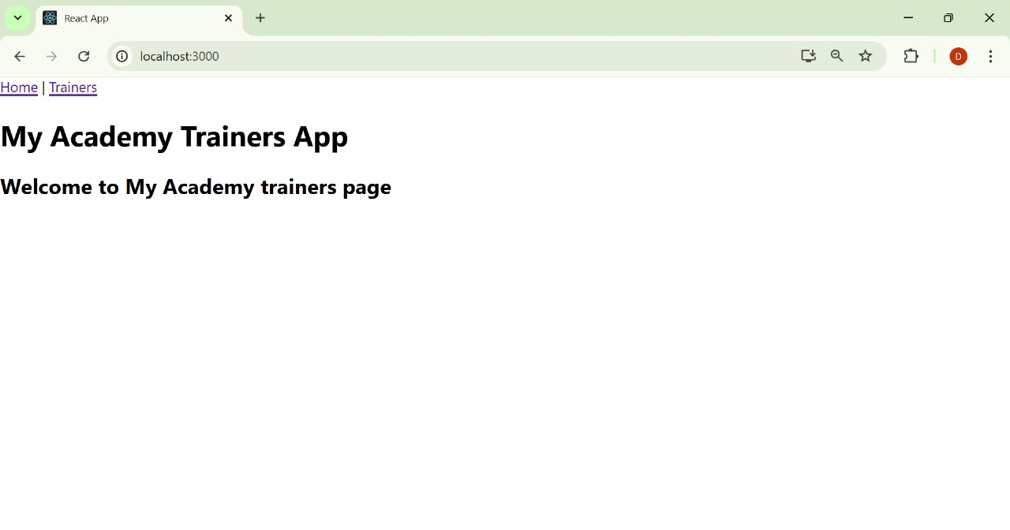

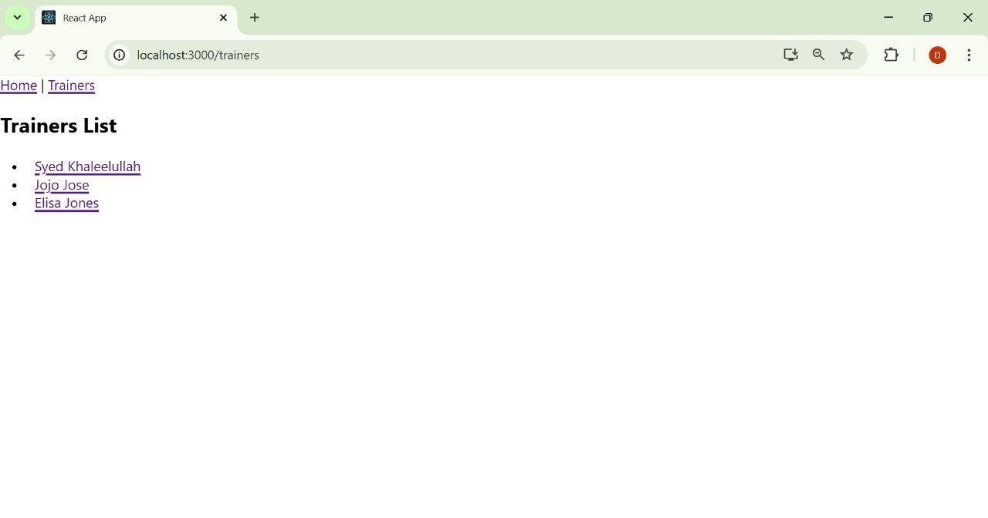

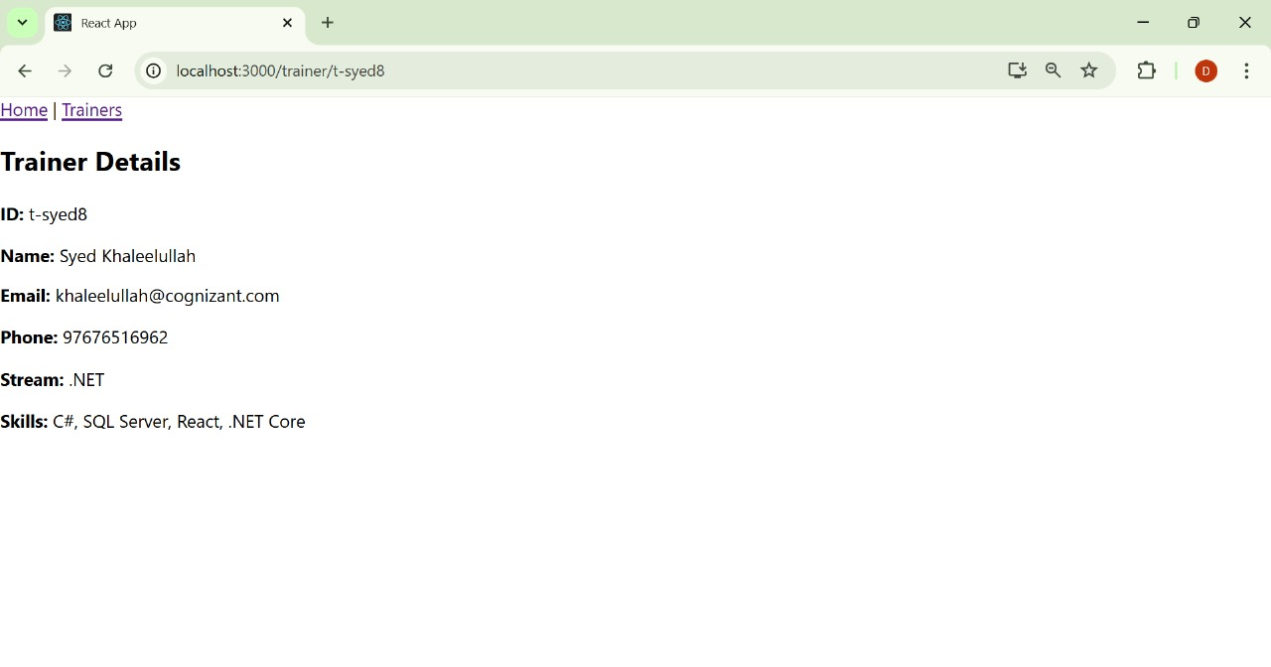

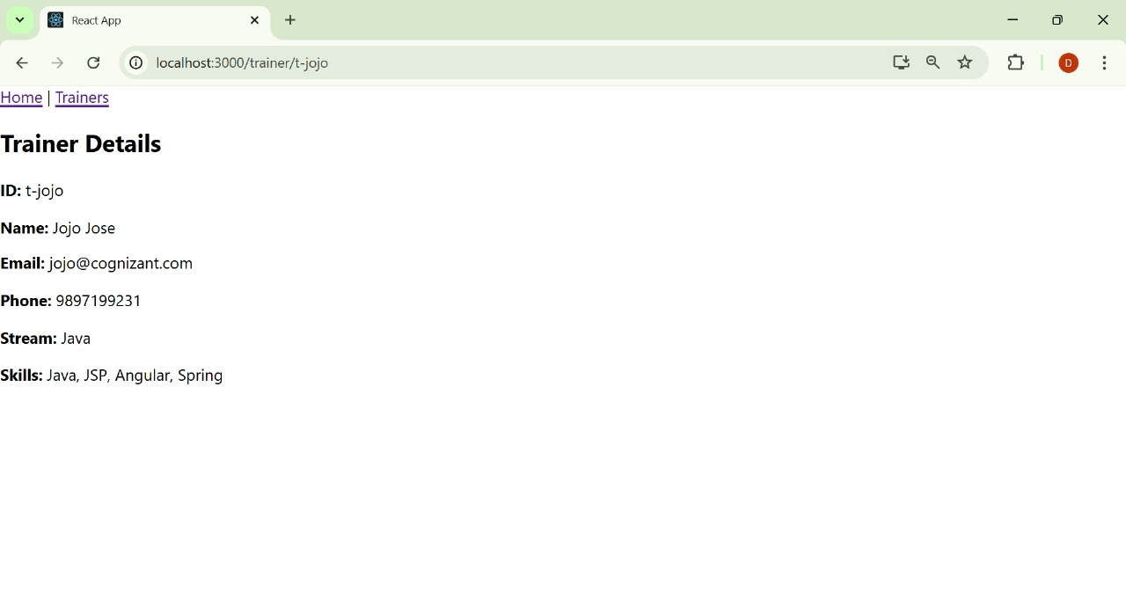

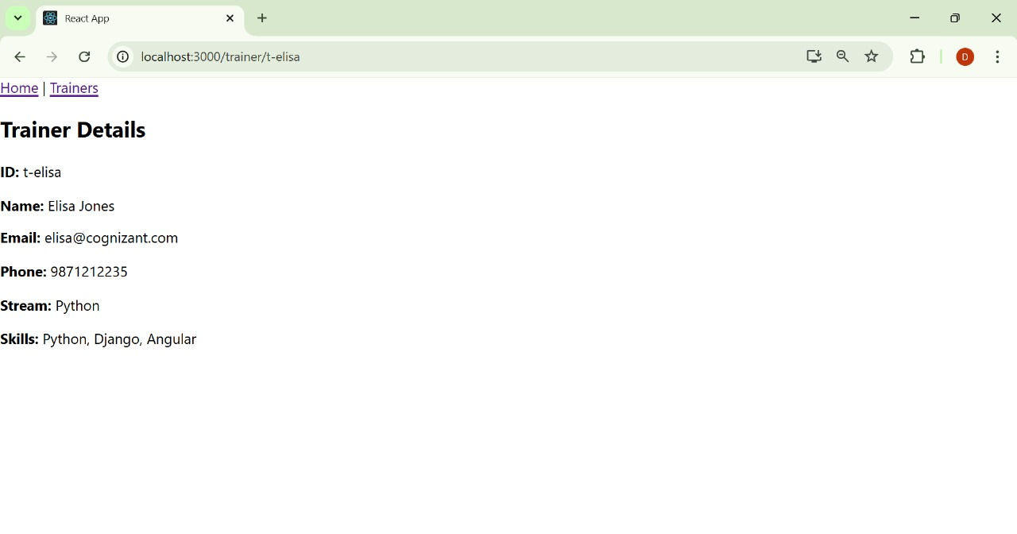

**7. ReactJS-HOL**

**Create a React Application named “shoppingapp” with a class component named “OnlineShopping” and “Cart”.**

**Code:**

**Cart.js**

import React, { Component } from 'react';

class Cart extends Component {

render() {

return (

<tr>

<td>{this.props.Itemname}</td>

<td>{this.props.Price}</td>

</tr>

);

}

}

export default Cart;

**OnlineShopping.js**

import React, { Component } from 'react';

import Cart from './Cart';

import './OnlineShopping.css'; // for custom styling

class OnlineShopping extends Component {

render() {

const items = [

{ Itemname: 'Laptop', Price: 80000 },

{ Itemname: 'TV', Price: 120000 },

{ Itemname: 'Washing Machine', Price: 50000 },

{ Itemname: 'Mobile', Price: 30000 },

{ Itemname: 'Fridge', Price: 70000 },

];

return (

<div className="container">

<h2 className="heading">Items Ordered :</h2>

<table className="item-table">

<thead>

<tr>

<th>Name</th>

<th>Price</th>

</tr>

</thead>

<tbody>

{items.map((item, index) => (

<Cart key={index} Itemname={item.Itemname} Price={item.Price} />

))}

</tbody>

</table>

</div>

);

}

}

export default OnlineShopping;

**OnlineShopping.css**

.container {

text-align: center;

margin-top: 50px;

}

.heading {

color: green;

font-weight: bold;

}

.item-table {

margin: 0 auto;

border-collapse: collapse;

width: 300px;

}

.item-table th, .item-table td {

border: 1px solid gray;

padding: 10px;

text-align: center;

color: teal;

}

.item-table th {

color: green;

}

**index.js**

import React from 'react';

import ReactDOM from 'react-dom/client';

import './index.css';

import OnlineShopping from './OnlineShopping';

const root = ReactDOM.createRoot(document.getElementById('root'));

root.render(<OnlineShopping />);

**Output:**

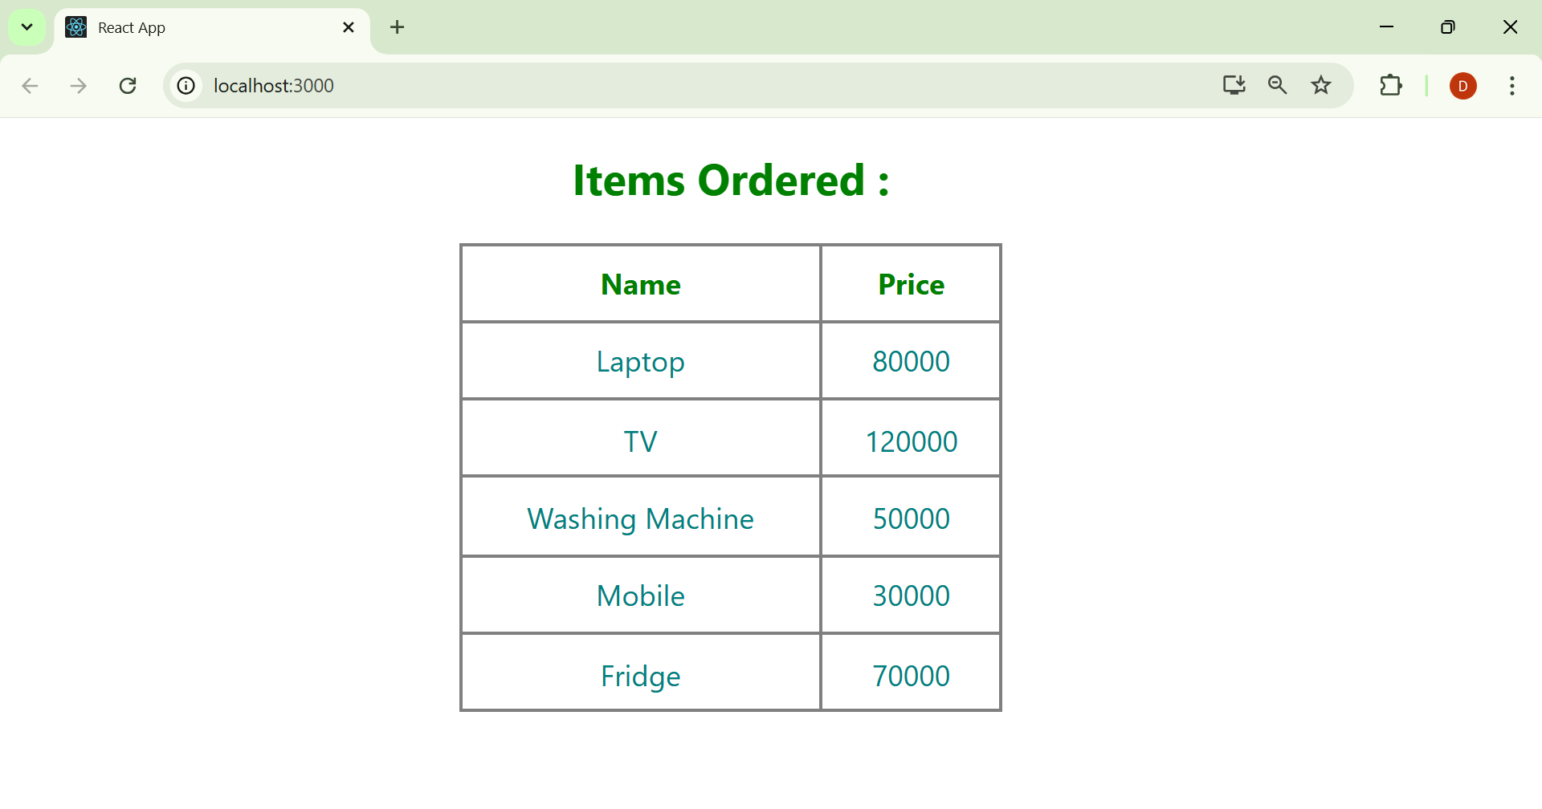

**8. ReactJS-HOL**

**Create a React App “counterapp” which will have a component named “CountPeople” which will have 2 methods.**

**Code:**

**CountPeople.js**

import React, { Component } from 'react';

class CountPeople extends Component {

constructor(props) {

super(props);

this.state = {

entryCount: 0,

exitCount: 0

};

}

updateEntry = () => {

this.setState((prevState) => ({

entryCount: prevState.entryCount + 1

}));

};

updateExit = () => {

this.setState((prevState) => ({

exitCount: prevState.exitCount + 1

}));

};

render() {

const buttonStyle = {

backgroundColor: 'lightgreen',

border: '1px solid green',

padding: '8px 16px',

fontWeight: 'bold',

cursor: 'pointer',

borderRadius: '5px',

marginRight: '10px'

};

const sectionStyle = {

display: 'flex',

justifyContent: 'space-around',

alignItems: 'center',

marginTop: '100px'

};

const textStyle = {

fontSize: '18px',

fontWeight: 'bold'

};

return (

<div style={sectionStyle}>

<div>

<button onClick={this.updateEntry} style={buttonStyle}>Login</button>

<span style={textStyle}>{this.state.entryCount} People Entered!!!</span>

</div>

<div>

<button onClick={this.updateExit} style={buttonStyle}>Exit</button>

<span style={textStyle}>{this.state.exitCount} People Left!!!</span>

</div>

</div>

);

}

}

export default CountPeople;

**App.js**

import React from 'react';

import CountPeople from './CountPeople';

function App() {

return (

<div className="App">

<CountPeople />

</div>

);

}

export default App;

**Output:**

